Annex No. 1

**Cartographical scheme of the Polotsk – Ventspils Trunk Oil Products Pipeline Crossing**

**Under the Pilsrundale–Svitene–Klieni (V1033) Highway**

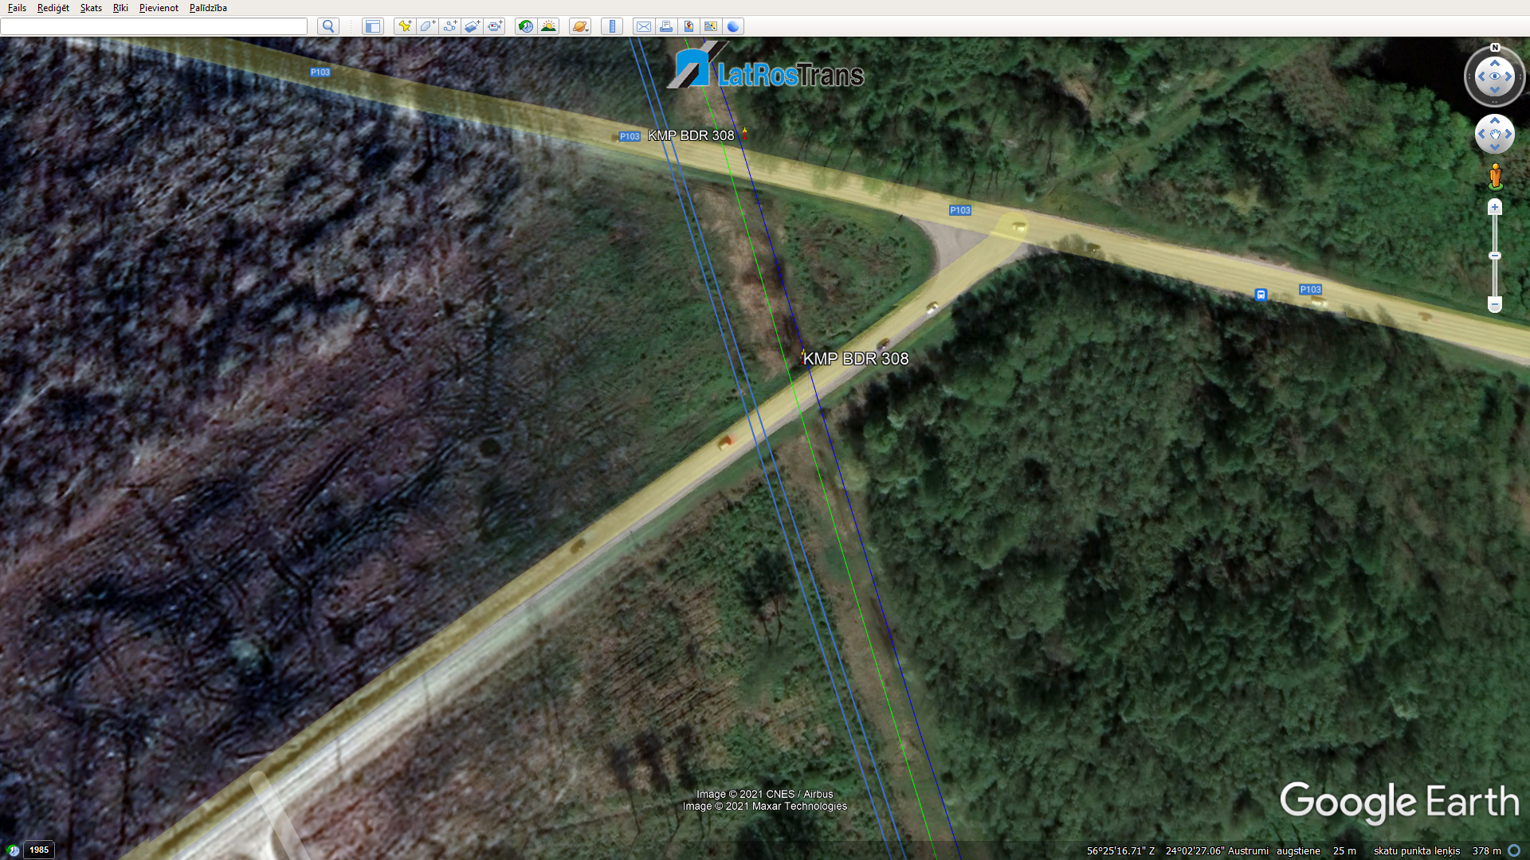

Location of the casing pipe under the highway

Pilsrundale–Svitene–Klieni (V1033) highway